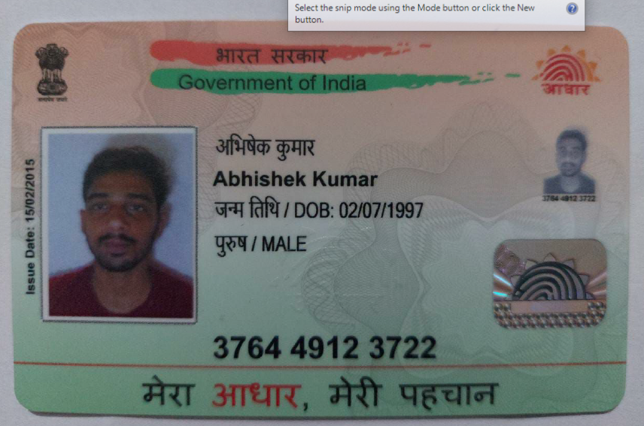
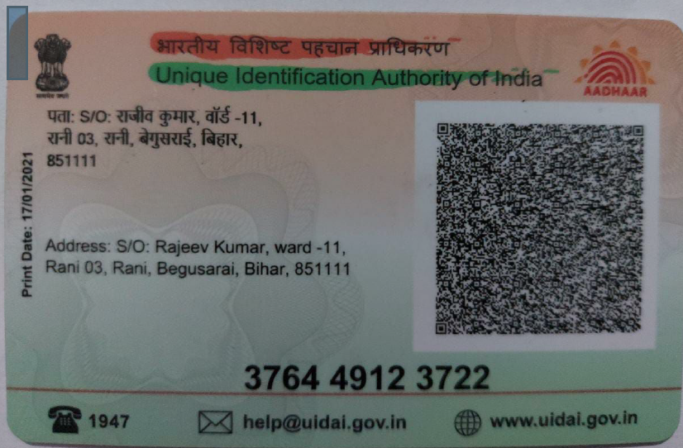

Video Link : Data Platform Engineer(Python) _ Interview _Abhishek Kumar-20230905_160426-Meeting Recording.mp4

PROFILE
Abhishek Kumar
Data Engineer
abhishekit297@gmail.com +917992323626 Bangalore, Karnataka www.linkedin.com/in/abhishekkumar297

Experienced Data Engineer with more than 2.8 years of experience, skilled in Python, SQL, Spark, PySpark, Hadoop, Hive and Cassandra with expertise in performance tuning. Committed to delivering high-quality, innovative data solutions for informed decision-making and business growth.

SKILLS

Programming Languages
Python, SQL

Big Data Frameworks
Hadoop, Spark, PySpark, Hive

EXPERIENCE

System Engineer
Tata Consultancy Services

Databases
MySQL, Cassandra

Cloud
Azure (Databricks, Data Lake)
Control Systems & Documentations Git, BitBucket, Jira

Others
Django, ReactJs

03/2021 – Present | Bangalore, India

Collaborated with cross-functional teams to identify data requirements and design optimal data solutions to support business intelligence and reporting needs.
Designed and developed ETL pipelines to extract, transform, and load data from diverse sources into a centralized data warehouse, ensuring accuracy and efficiency.
Conducted performance tuning on data pipelines, enhancing overall system performance and reliability. Applied data transformation techniques, leveraging Pandas and SQL, to convert raw data into actionable insights, reducing analysis time by 40%.
Contributed to a collaborative Agile workspace, tracking work using Jira to ensure seamless collaboration with team members.
Developed a dashboard using React.js and represented data graphically using ApexCharts.js and integrated more than 50 API's.

Software Developer Intern
Inovant Technologies
10/2020 – 12/2020 | Pune, India

Developed a serverless application using ReactJS and AWS, effectively leveraging AWS Lambda, API Gateway, and S3 for scalable and cost-efficient architecture.
Constructed a comprehensive data visualization dashboard using Microsoft Power BI, transforming raw data into actionable insights and enhancing the organization's data-driven strategy.

EDUCATION

Bachelor of Technology in Information Technology
Asansol Engineering College

CERTIFICATES
2016 – 2020 | Asansol, India

SQL Intermediate Certification (Hackerrank) Python Certification (Hackerrank)

ACHIEVEMENTS

On The Spot Award : Awarded four times by TCS in recognition of exceptional performance and contribution to the project.
Learning and Achievement Award : Awarded by TCS in recognition of top performer in the tagged unit.

